Creating Repository on Github.com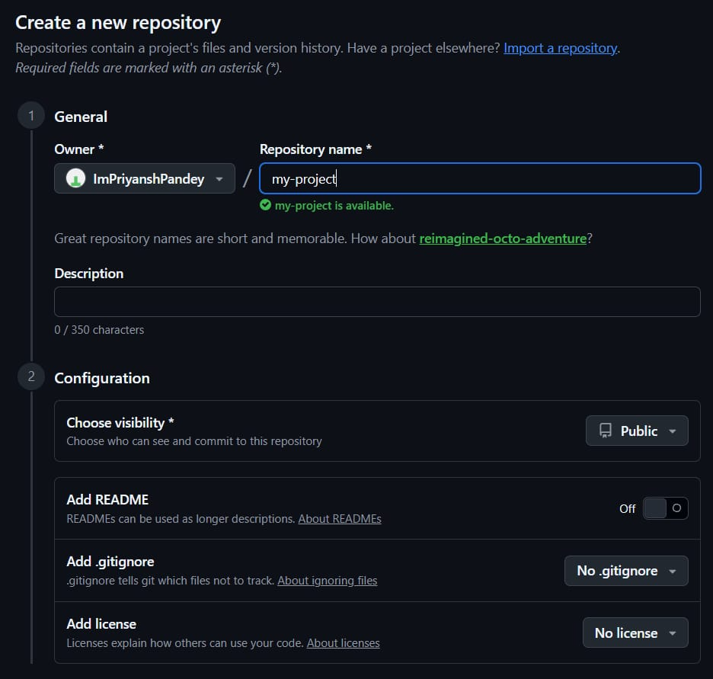
Identification and installation and then Push to GitHub using terminal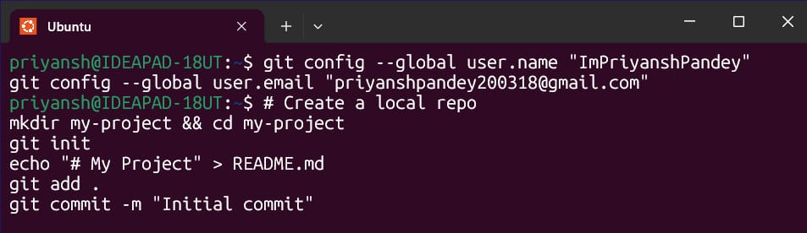
NOTE: You'll need to enter your Username and then password (which will be a token we'll generate on github.com) 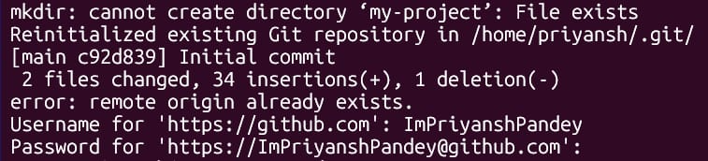
To Generate Token (for password) -
Go to Settings < Developer Settings < Personal Access Tokens < Tokens (classic)
Generate New Token < Token Classic < Enter the name 'my-project'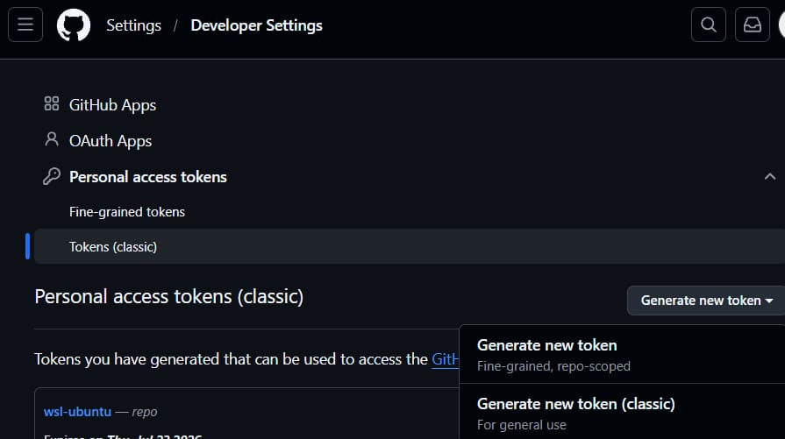
Enter the name - my-project
Select 'repo' checkbox only and then click generate at the bottom of the screen
NOTE: Make sure to save the key after generating as you won't be able to see it again.
This key will be used for password in our terminal connection.
[This is because GitHub removed direct terminal connection through passwords a while back.] 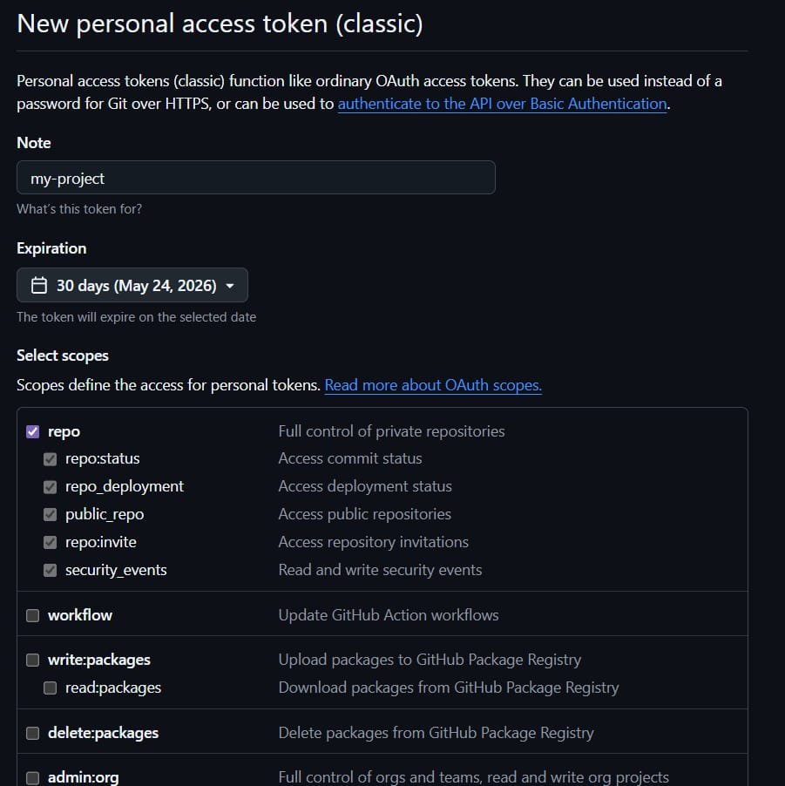
After entering the key as the password the Git will initialize and then push the request which we wanted to do earlier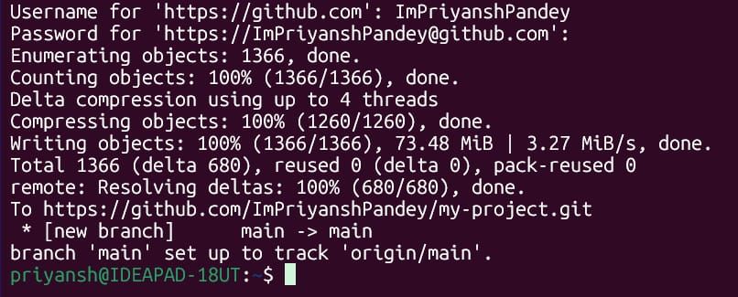
Clone the repository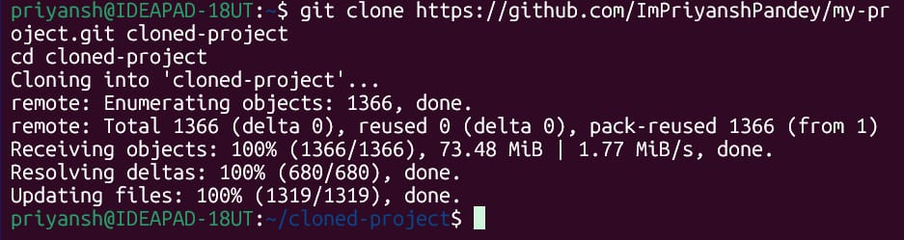
Select a repository to fork (we're using this very simple one) -
https://github.com/octocat/Hello-World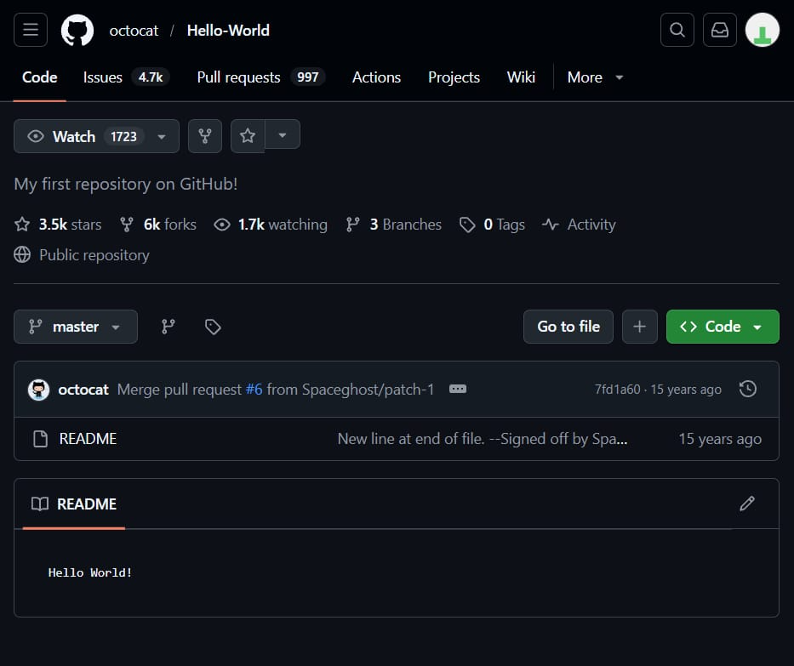
Use Fork Button to fork this repo
Enter the details -
Name, description, etc...
Click Create Fork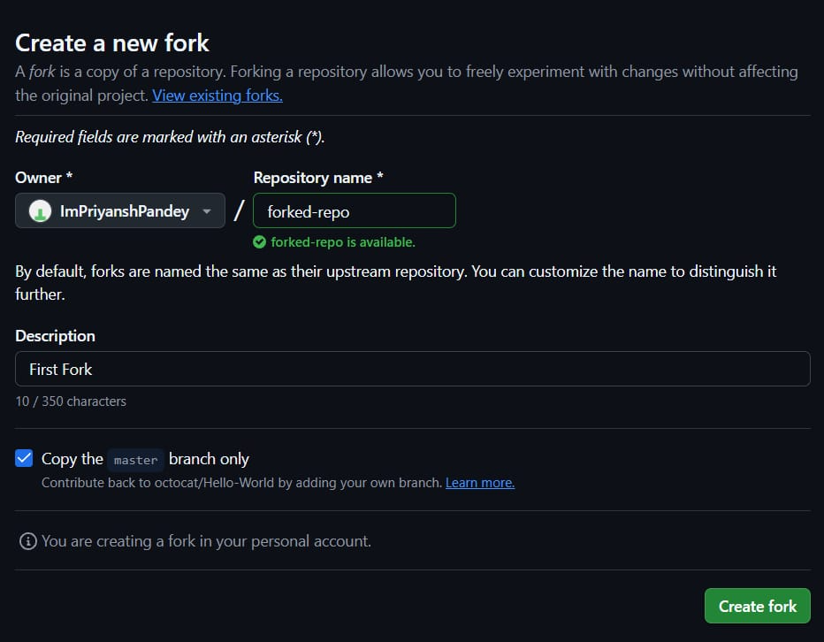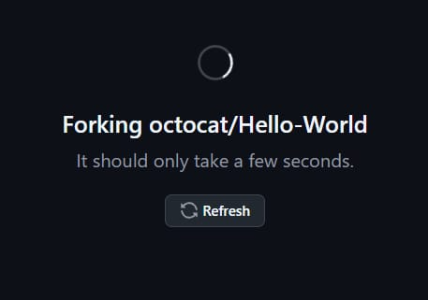
Forked Repo will be visible in profile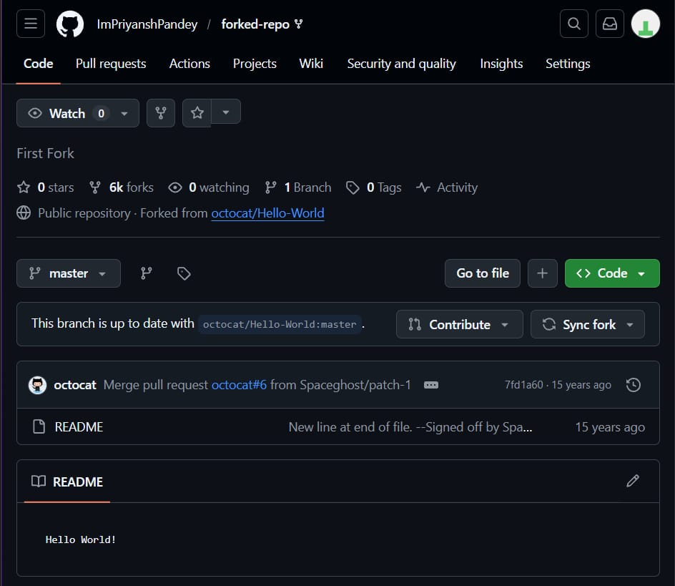
Fork and Pull Request (Locally)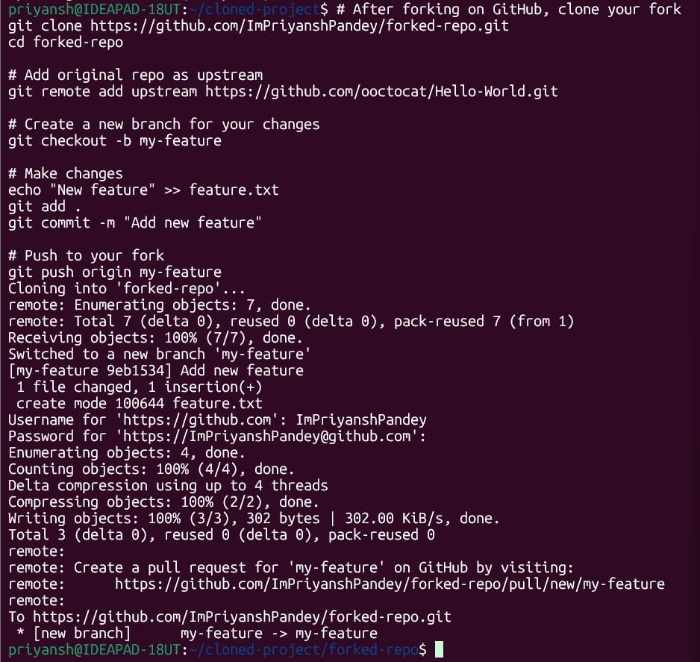
Go to the given URL in the terminal.
Then just click 'create pull request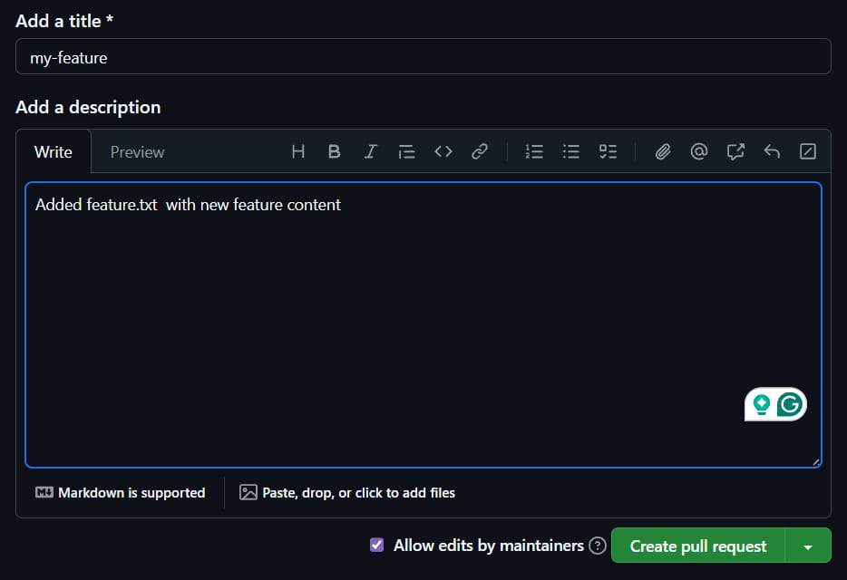
No Conflict = Success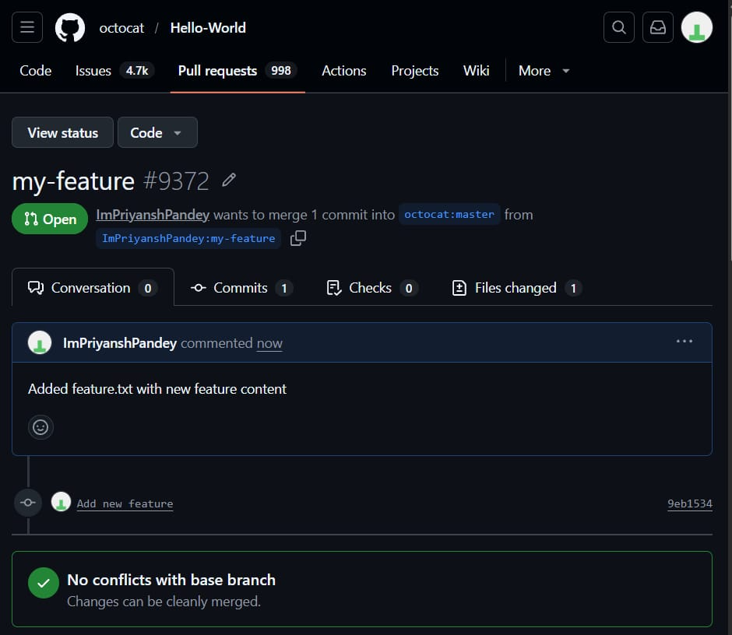
Check status and pull the latest changed from Terminal